**AI BASED ATTENDANCE SYSTEM USING FACE RECOGNITION**

**By**

**Kaushal Adeshra (19BCA056)**

**Shivam Barot (19BCA057)**

**Harshil Suthar (19BCA058)**

Under Guidance

of

Internal Guide

**DR. KANUBHAI PATEL**



Smt. Chandaben Mohanbhai Patel Institute of Computer Applications

CHARUSAT

Changa



[Accredited with Grade A by NAAC,  
Accredited with Grade A by KCG](https://www.charusat.ac.in/)

CHAROTAR UNIVERISTY OF SCIENCE & TECHNOLOGY

Changa

April-2022

**Acknowledgement**

Knowledge in itself is a continuous process. At this moment of our substantial enhancement, we rarely find words to express our gratitude towards those who were constantly involved with us.

The completion of any inter disciplinary project depends upon coordination, cooperation and combined efforts of several resources of knowledge, creativity, skill, energy and time. The work being accomplished now, We feel our most sincere urge to recall and knowledge through these lines, trying our best to give full credit wherever it deserves.

We would like to thank our project guide **Dr. KANUBHAI PATEL** and Dean & Principal

**Dr. Atul Patel** who advised and gave us moral support through the duration of our project. Without their constant encouragement we could not have been able to achieve what we have.

It’s our good fortune that we had support and well wishes of many. We are thankful to all and those names which have been forgotten to acknowledge here but contributions have not gone unnoticed.

With Sincere Regards,

**Kaushal Adeshra (19BCA056)**

**Shivam Barot (19BCA057)**

**Harshil Suthar (19BCA058)**

**Table of Contents**

Abstract 4

Introduction 6

Software Requirements Specification - SRS 7

Design 10

**Class Diagram** 10

**Use case Diagram** 11

**Activity Diagram** 12

**Data Dictionary** 21

Implementation Details 16

**Modules** 16

**Function prototypes which implement major functionality** 16

Testing 17

Screenshots 19

Conclusion 26

Limitation and Future Extensions 27

● **Limitations** 27

● **Functionalities not implemented** 27

● **Possible future extensions** 27

Refrencese

# **Abstract**

This project involves building an attendance system which utilizes facial recognition to mark the presence, time-in, and time-out of Users. It covers areas such as facial detection, alignment, and recognition, along with the development of a web application to cater to various use cases of the system such as registration of new Users, addition of photos to the training dataset, viewing attendance reports, etc. This project intends to serve as an efficient substitute for traditional manual attendance systems. It can be used in corporate offices, schools, and organizations where security is essential.

**Purpose**

The purpose of this document is to specify software requirements of the Attendance Management System Using Face Recognition. It is intended to be a complete specification of what functionality the Attendance Management System provides.

Furthermore, this project aims to automate the traditional attendance system where the attendance is marked manually. It also enables an organization to maintain its records like in-time, out time, break time and attendance digitally. Digitalization of the system would also help in better visualization of the data using graphs to display the no. of Users present today, total work hours of each User and their break time. Its added features serve as an efficient upgrade and replacement over the traditional attendance system.

**Scope**

Facial recognition is becoming more prominent in our society. It has made major progress in the field of security. It is a very effective tool that can help low enforcers to recognize criminals and software companies are leveraging the technology to help users access the technology. This technology can be further developed to be used in other avenues such as ATMs, accessing confidential files, or other sensitive materials.

# This project servers as a foundation for future projects based on facial detection and recognition. This project also convers web development and database management with a user-friendly UI. Using this system any corporate offices, school and organization can replace their traditional way of maintaining attendance of the Users and can also generate their availability(presence) report throughout the month.

# 

# **Introduction**

## **Brief Introduction**

This project aims to automate the traditional attendance system where the attendance is marked manually. It also enables an organization to maintain its records like in-time, out time, break time and attendance digitally. Digitalization of the system would also help in better visualization of the data using graphs to display the no. of Users present today, total work hours of each User and their break time. Its added features serve as an efficient upgrade and replacement over the traditional attendance system.

## **Technology/Platform/Tools used**

**Technology:**

* Django
* OpenCV
* Dlib
* Open-Source Face Recognition Library
* SQLITE Database.
* HTML, CSS, JavaScript
* Bootstrap

**Platform:**

* Windows

**Tools:**

* PyCharm

# **Software Requirements Specification - SRS**

We have 2 types of users of the system.

1. User
2. Admin

Following functionalities can be performed by the admin:

* Login
* Register new User to the system
* Add User photos to the training data set
* Train the model
* View attendance report of all Users. Attendance can be filtered by date or User.

Following functionalities can be performed by the User:

* Login
* Mark his/her time-in and time-out by scanning their face
* View attendance report of self

## **Functional Requirements**

**1.1 Manage Registration and Login**

**1.1.1 Register new User**

Description: Admin can register new

Input: User Details

Output: success message displaying the user has been created.

**1.1.2 Log-In to the system**

Input: User credentials

Output: If the credentials are correct, user will be redirected to the dashboard of the system

Exception Flow: If the entered credentials are incorrect then user will be redirected to the login page again displaying an error message.

**1.2 Manage Attendance Details**

**1.2.1 Mark your attendance-in**

Input: User will scan his/her face using the external web camera.

Output: system will identify the user uniquely and will mark his/her in-time to the database. The same success message will be transmitted to the user.

**1.2.2 Mark your attendance-out**

Input: User will scan his/her face using the external web camera.

Output: system will identify the user uniquely and will mark his/her out-time to the database. The same success message will be transmitted to the user.

**1.2.3 View my attendance report**

Description: User may often need to see his / her attendance record throughout the month or year. Using this feature one can see his / her attendance record till the date.

Input: User selection

Output: Statistical analytics of the particular User who is currently logged into the system will be displayed.

**1.2.4 View User’s attendance report**

Description: This feature is for admin. Admin can monitor the availability of each User till the date. i.e., how many Users are present today out of total Users etc. can be monitored.

Input: user selection

Output: Attendance record of each User including how many Users are present today out of total along with the availability graph.

**1.3 Manage User Details**

**1.3.1 Add photo of the User**

Description: Admin only can access this feature. Admin can add a photo of a User during the registration process.

Input: Username of a User

Output: Success message record has been added.

Process: System will process an image and will generate necessary system data to identify each User uniquely.

**1.3.2 Analyze the User Details**

Input: user selection

Output: system will process all the available records of the Users and will generate necessary system data to identify each User uniquely.

# **Design**

## **Class Diagram**

## **Use case Diagram**

## **Activity Diagram**

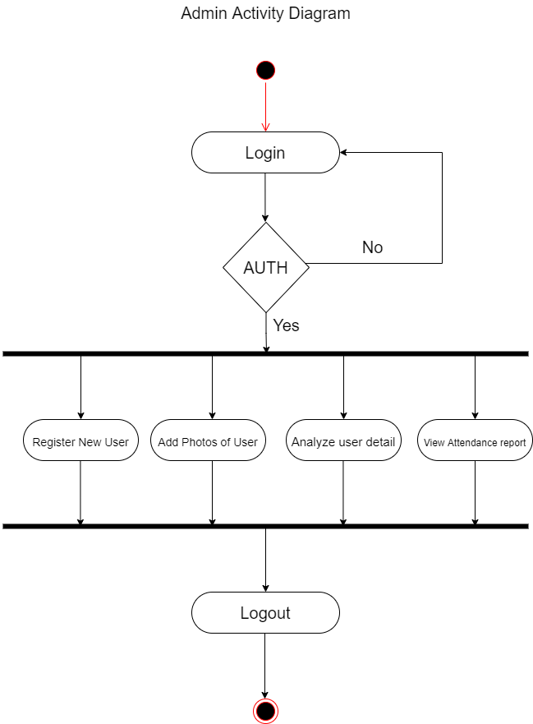

## 

**Data Dictionary**

### **User**

|  |  |  |  |  |  |  |
| --- | --- | --- | --- | --- | --- | --- |
| **No** | **Field name** | **Data type** | **Required** | **Unique** | **PK / FK** | **Ref. Table** |
| 1 | UserId | int | true | true | PK | - |
| 2 | Email | string | true | true | - | - |
| 3 | Name | string | true | false | - | - |
| 4 | Password | string | true | false | - | - |
| 5 | CreatedAt | Datetime | true | false | - | - |
| 6 | UpdatedAt | Datetime | True | False | - | - |

### **Present**

|  |  |  |  |  |  |  |
| --- | --- | --- | --- | --- | --- | --- |
| **No** | **Field name** | **Data type** | **Required** | **Unique** | **PK / FK** | **Ref. Table** |
| 1 | PId | int | true | true | PK | - |
| 2 | Date | Datetime | True | False | - | - |
| 3 | User | User | True | False | FK | Users |
| 4 | Present | Boolean | True | False | - | - |

### 

### 

### **Time**

|  |  |  |  |  |  |  |
| --- | --- | --- | --- | --- | --- | --- |
| **No** | **Field name** | **Data type** | **Required** | **Unique** | **PK / FK** | **Ref. Table** |
| 1 | TId | int | true | true | PK | - |
| 2 | Date | Datetime | true | True | - | - |
| 3 | User | Users | True | False | FK | Users |
| 4 | Time | Datetime | False | False | - | - |
| 5 | Out | Boolean | True | False | - | - |

### 

# **Implementation Details**

## **Modules**

The features of the system are mainly divided into 3 modules.

**Registration and Login Module**

This module mainly deals with the functionalities related to the registration of any new User to the organization, Log into the system and managing User’s profile details. Using features provided by this module admin can register new User to the system and admin / User both can log into the system using their credentials.

**Manage Attendance Details**

This module mainly deals with the features related to the User’s attendance. Using this User can mark their presence, time-in and time-out in the system. Admin can see the availability report of each User, User can see his/her attendance report along with some possible filters such as filter by User and filter by date.

**Manage User Details**

This module mainly deals with the features related to the User’s profile. Using this admin can add a photo of the newly registered User during registration. Admin can also command the system explicitly to train the model and system will make necessary calculation and will generate some data which will be used internally to identify each User uniquely.

## **Function prototypes which implement major functionality**

* List<Attendance> viewMyAttendanceReport(int empId);
* Int totalUsersRegistered();
* List<Attendance> getAttendanceRecordByUser(int empid);
* Boolean updateAttendanceRecord(int empid, Attendance update);
* Boolean registerUser(User new_User);
* Boolean addPhoto( int empId, string photo);

# **Testing**

Unit testing of each module was done after successfully completing the module. Each module was tested individually before integrating them with the whole system.

After integrating each module with the system, integration testing was done in order to check if modules are working properly together.

After completing all integrations, black-box testing of the whole system was carried out to ensure the system works in a correct manner.

**Black box testing of Major functions of the system**

### **Log in to the system.**

**Case 1:** Invalid Username or password entered by the user.

**Output:** Error message on the screen saying “Invalid credentials”

**Case 2:** Valid credentials.

**Output:** The user is redirected to the Dashboard page.

### **Update Profile**

**Case 1:** username already exists.

**Output:** Error message on the screen saying “Username already exists”

**Case 2:** Some of required fields missing in input.

**Output:** Model validation errors will be displayed to the user.

**Case 3:** All input data are valid.

**Output:** Profile updated successfully.

### **View Attendance.**

**Case 1:** User is not logged in.

**Output:** Redirected to the login page with error message “Please login!”.

**Case 2:** If a user exists and has the attendance records.

**Output:** All the chat history will be displayed

**Case 4:** Provided username does not exist in the system.

**Output:** 404 Error.

# 

# **Screenshots**

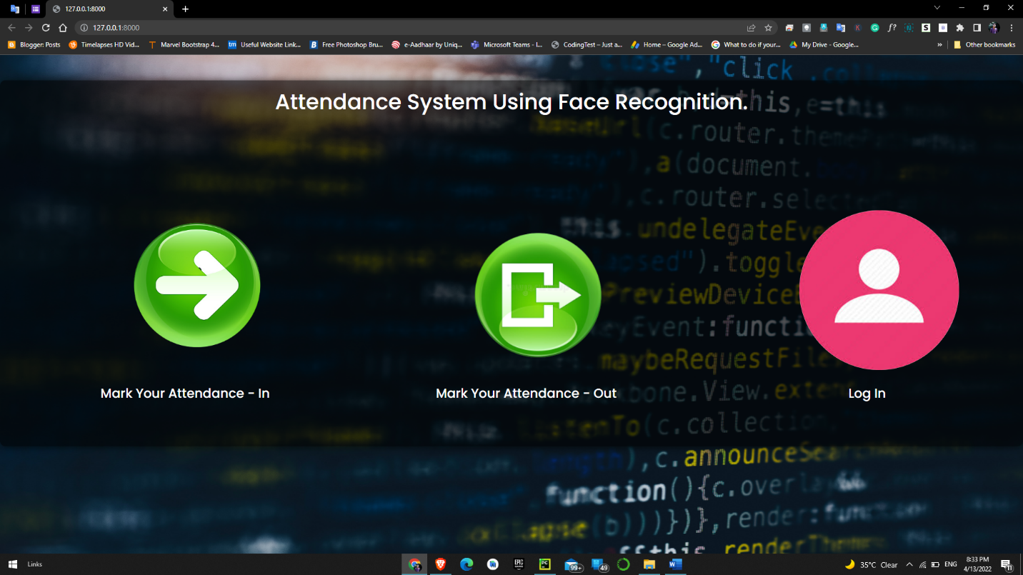**Login**

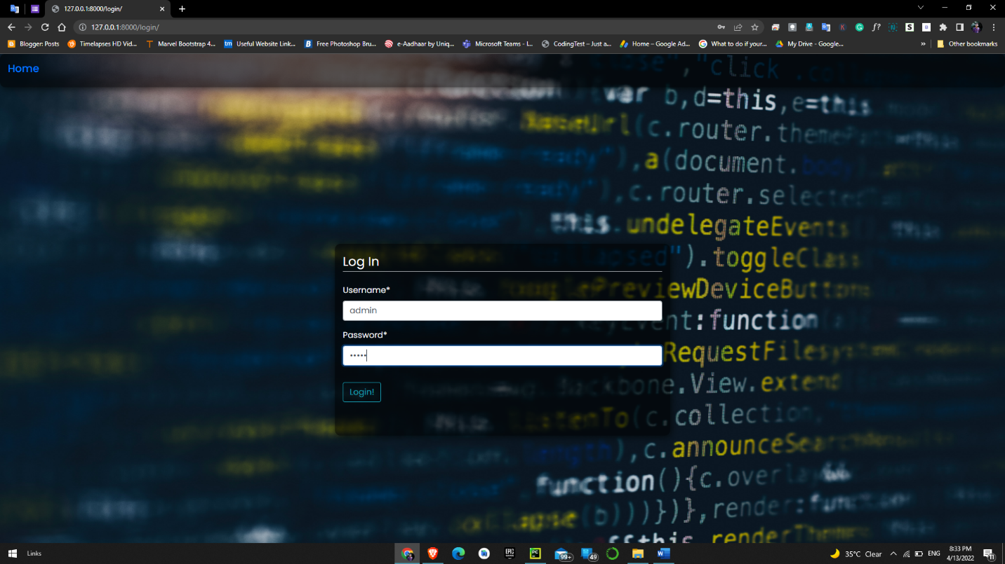

**Mark my attendance In / Out**

**Scanning Face**

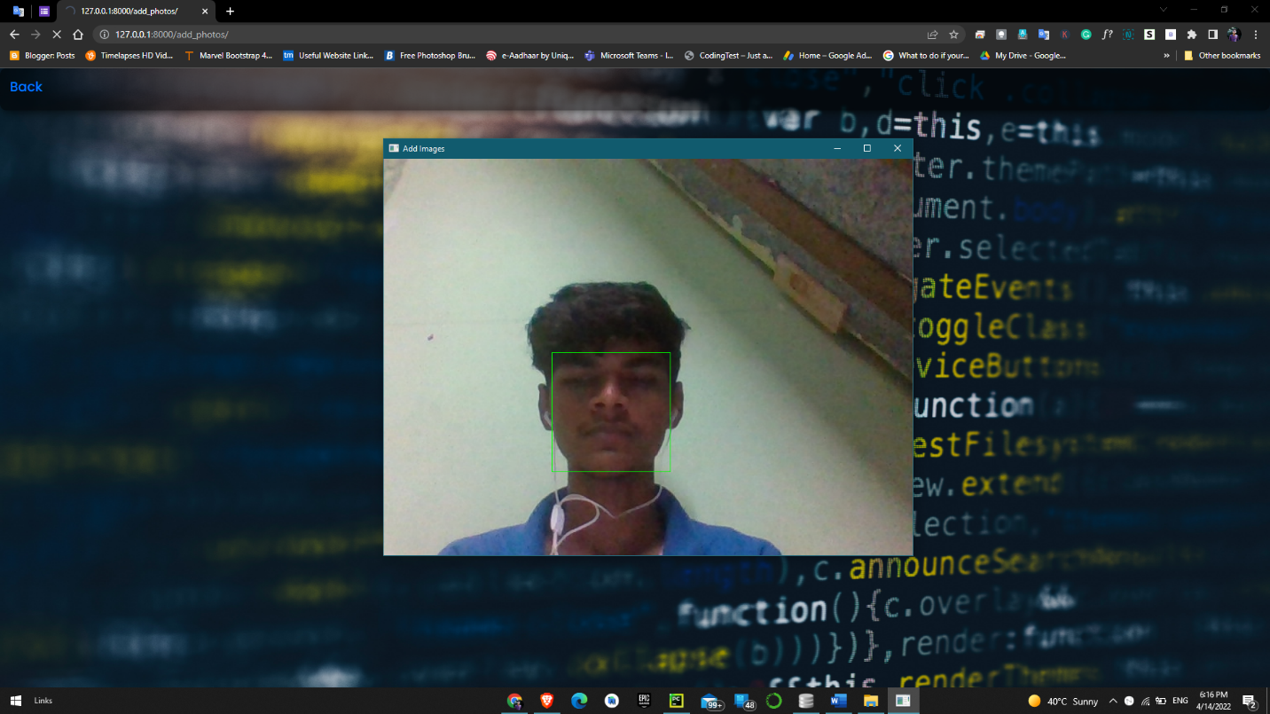

**View Attendance Records by Admin**

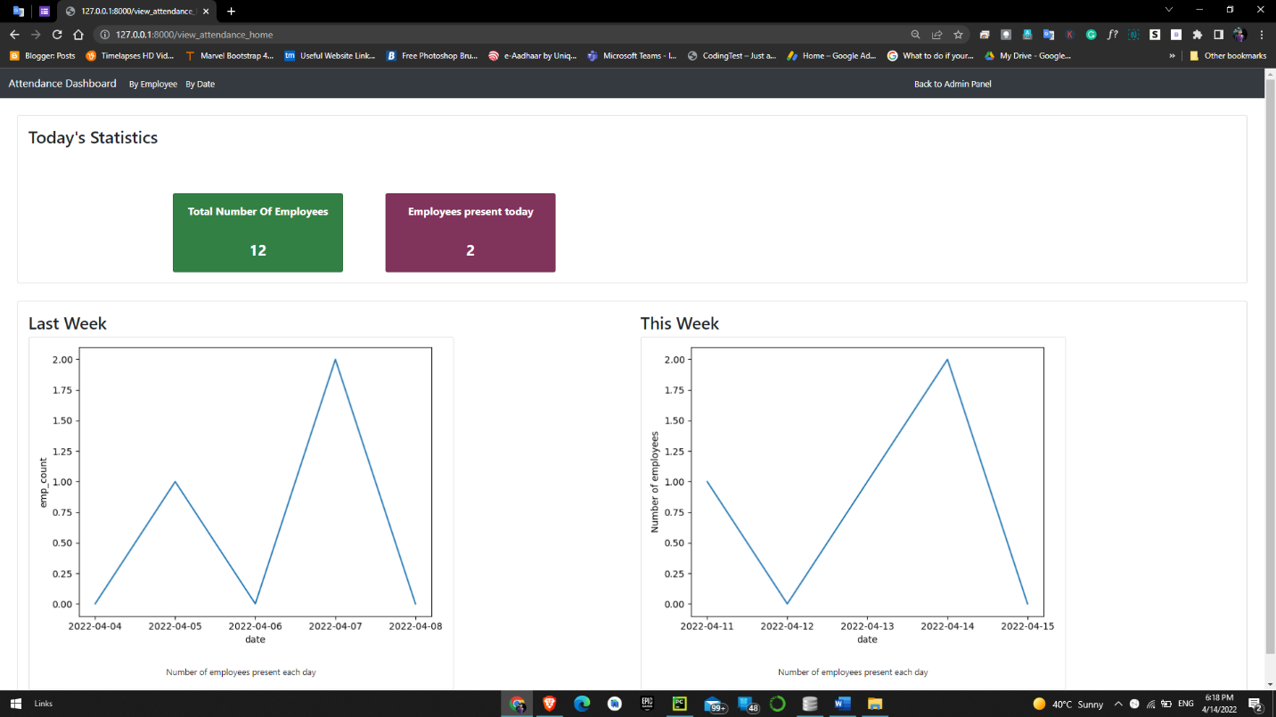

**Trained Dataset Output**

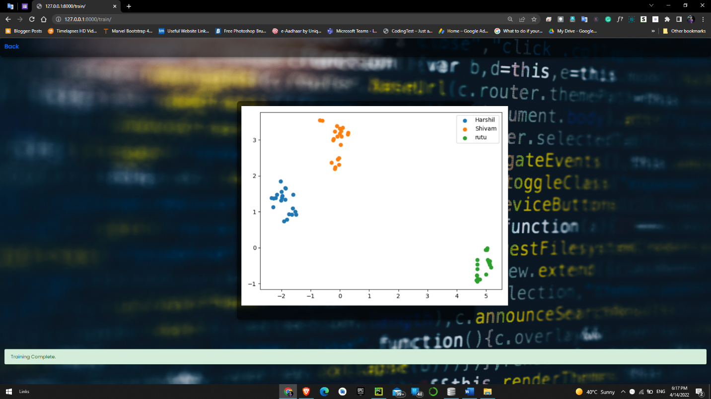



**Add Photos**

**User Dashboard**

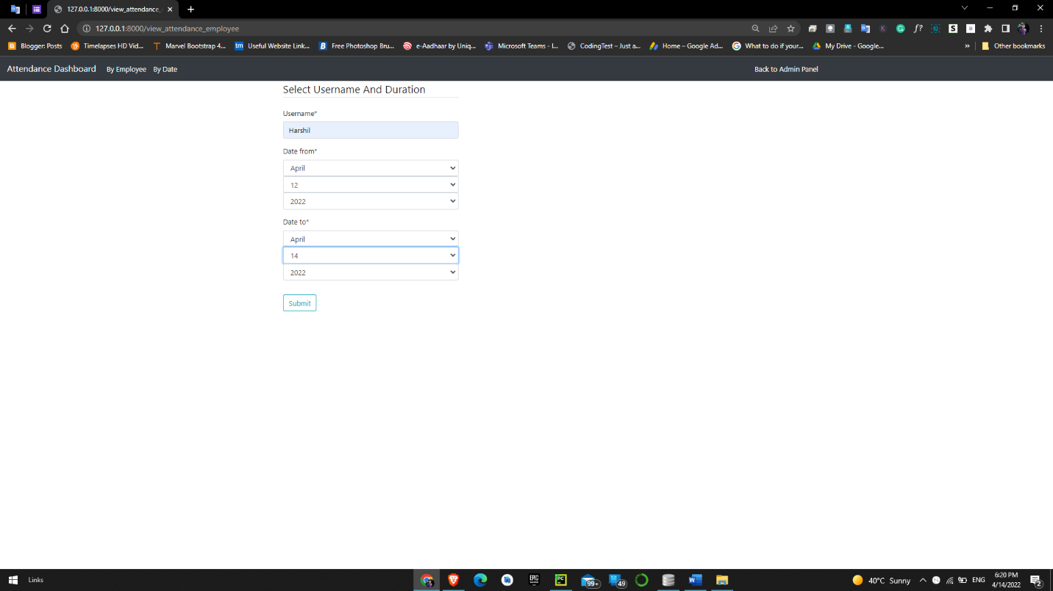

**View My Attendance by User**

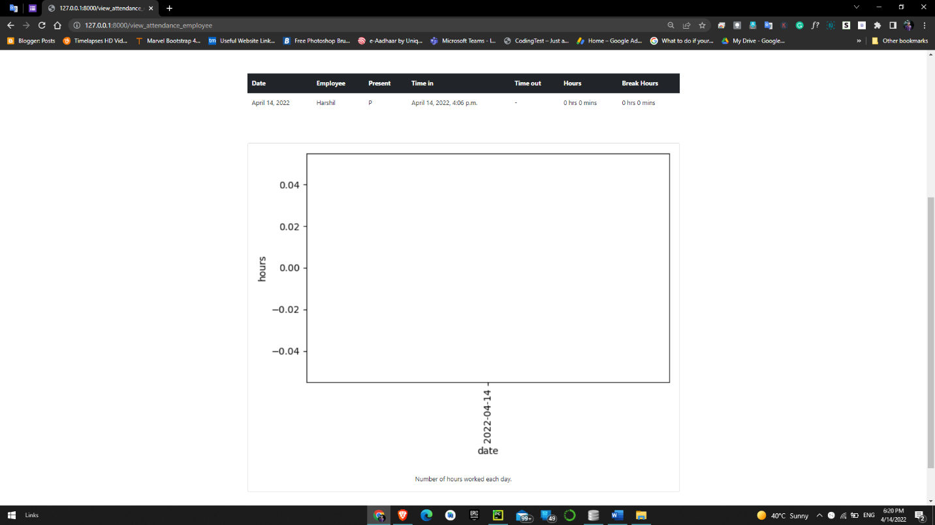

**Admin can filter attendance by User / by date**

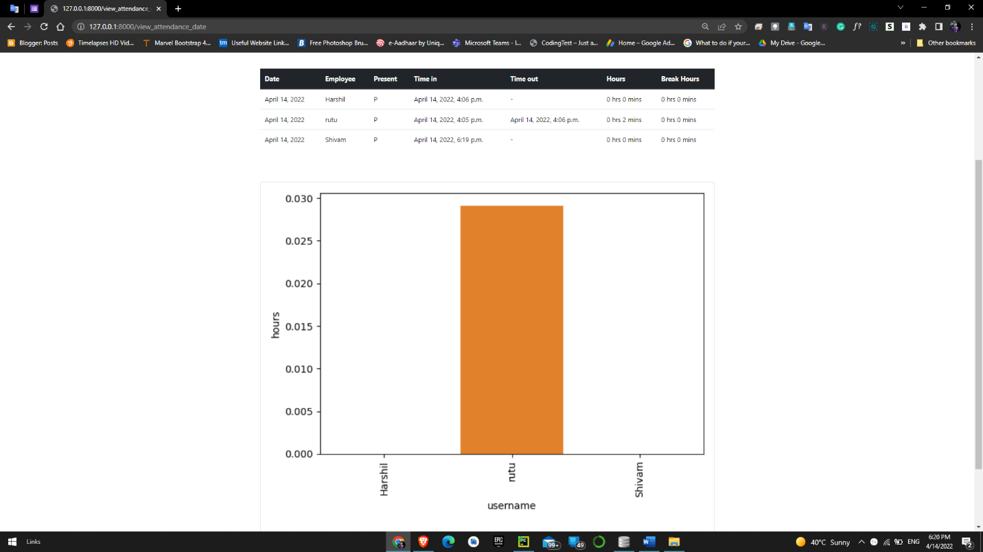

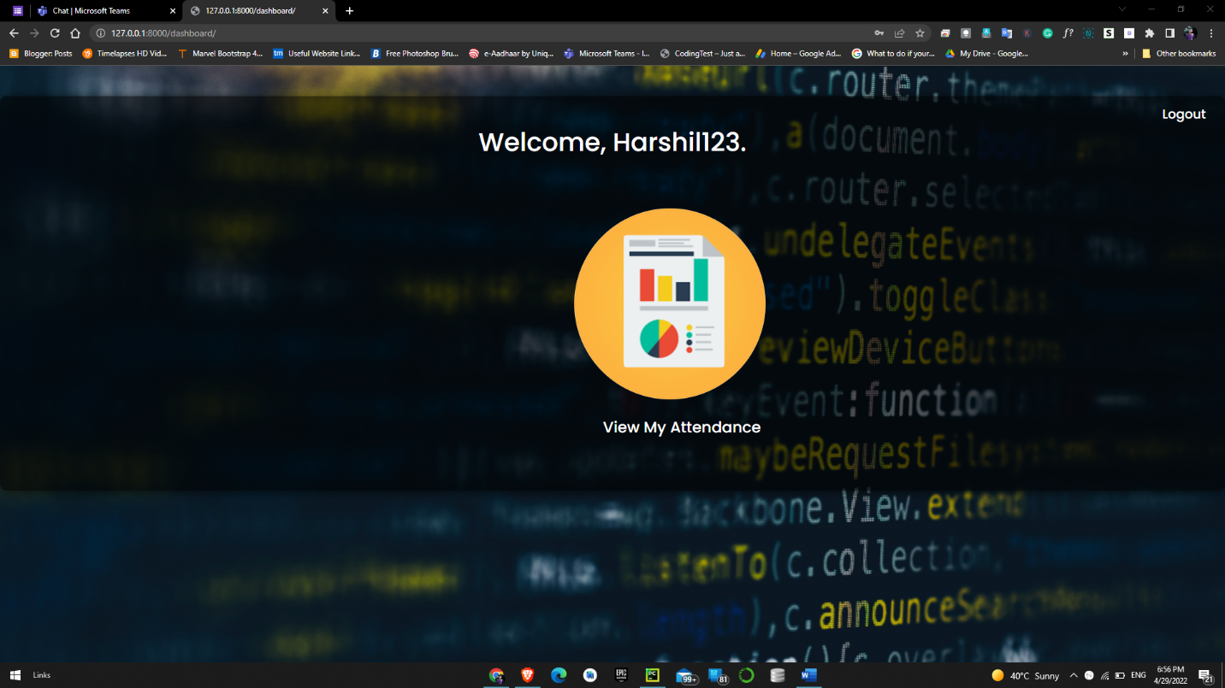**View Report from User Side**

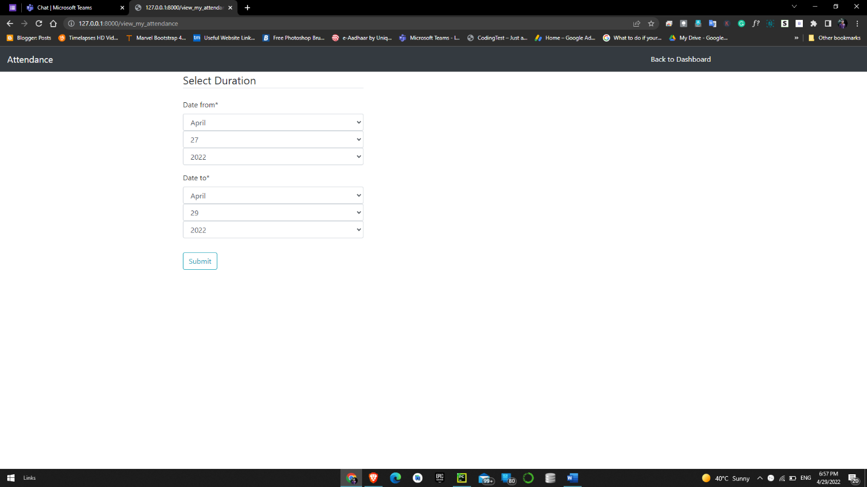

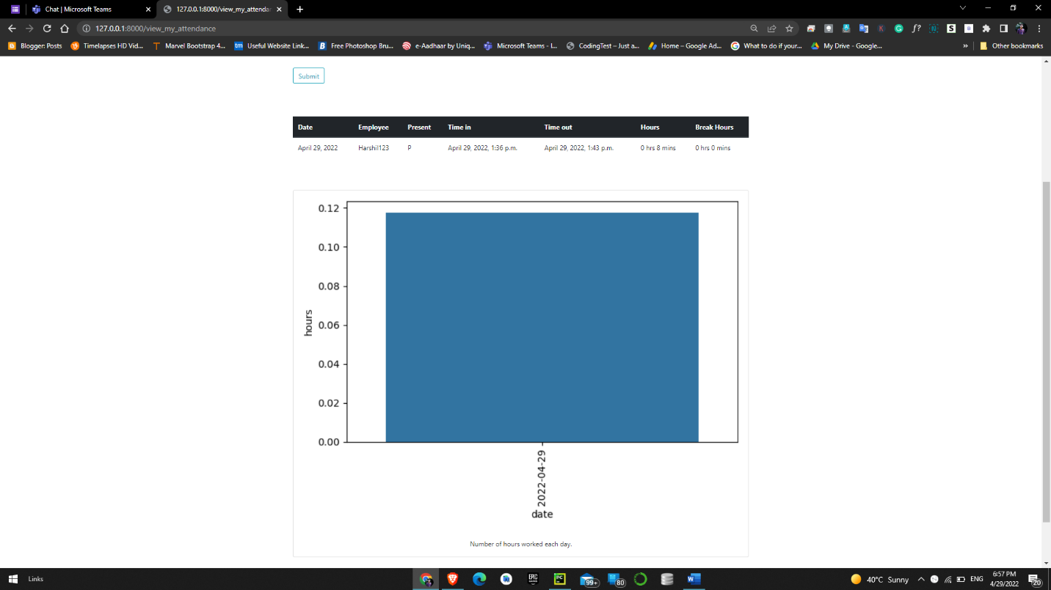

# **Conclusion**

**Functionalities implemented successfully:**

* Registration
* Login / Logout
* Manage User Profile
* Update user profile
* View My Attendance
* View Attendance by Date
* View Attendance by User
* Manage Attendance
* Mark my attendance In
* Mark my attendance Out
* Add photos
* Add new User
* Train the system
* View Attendance record by date
* View no. of User present today
* View Total number of Users

# **Limitation and Future Extensions**

## **Limitations**

* Attendance can be marked if the picture of an User is shown
* 20 images of each User are taken for better accuracy. 300 Images per User in a larger organization would consume a massive volume to store the images.
* The training time for our classifier takes about 20 seconds for each person. Hence for a large number of Users, it would take a very long time to train. Though training the classifier isn’t something that needs to be frequently done, but it would be better if a classifier taking lesser time while maintaining the accuracy can be built.
* The current model is 99.38% Accurate

## **Functionalities not implemented**

* Alert System
* Forgot Password
* Email Notifications

## **Possible future extensions**

* A feature which can give intruder alert can be included in the system. Furthermore, the images of unknown people can be saved in an efficient manner and displayed in the system for better security.
* The number of training images can be reduced so that less storage is required. This can be done by removing duplicate images of the same person, or images with similar embeddings.
* The training time can be reduced by retraining the classifier only for the newly added images.
* A feature can be added where an User is automatically sent a warning if his attendance or working hours are below the threshold.
* Wrongly classified images can be added to the training dataset with the correct label so as to increase the accuracy of the recognition model.

# **References**

[**The Web framework for perfectionists with deadlines | Django (djangoproject.com)**](https://www.djangoproject.com/)

[**https://medium.com/**](https://medium.com/)

[**http://dlib.net/**](http://dlib.net/)

[**https://opencv.org/**](https://opencv.org/)

* CSS & Bootstrap:

[**https://getbootstrap.com/**](https://getbootstrap.com/)

* For debugging:

[**https://stackoverflow.com/**](https://stackoverflow.com/)

**THANK YOU**